Administrative Home Page

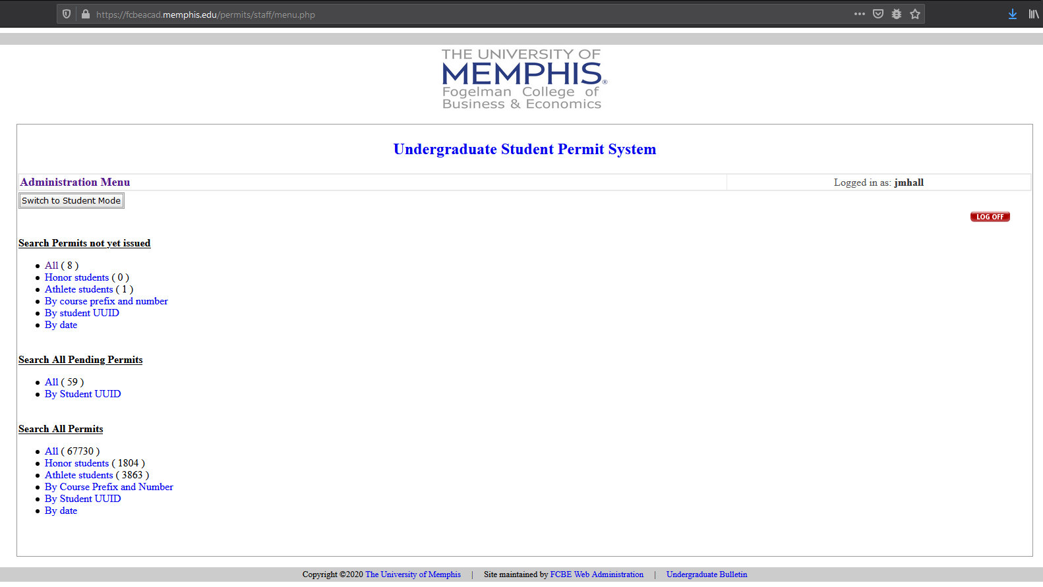

List of Open | Pending Permit Requests

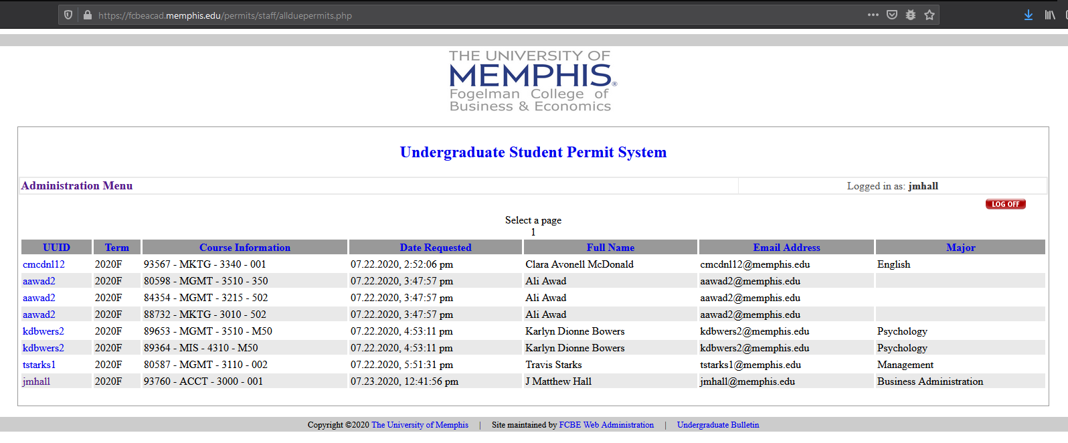

Student Permit Request – Details

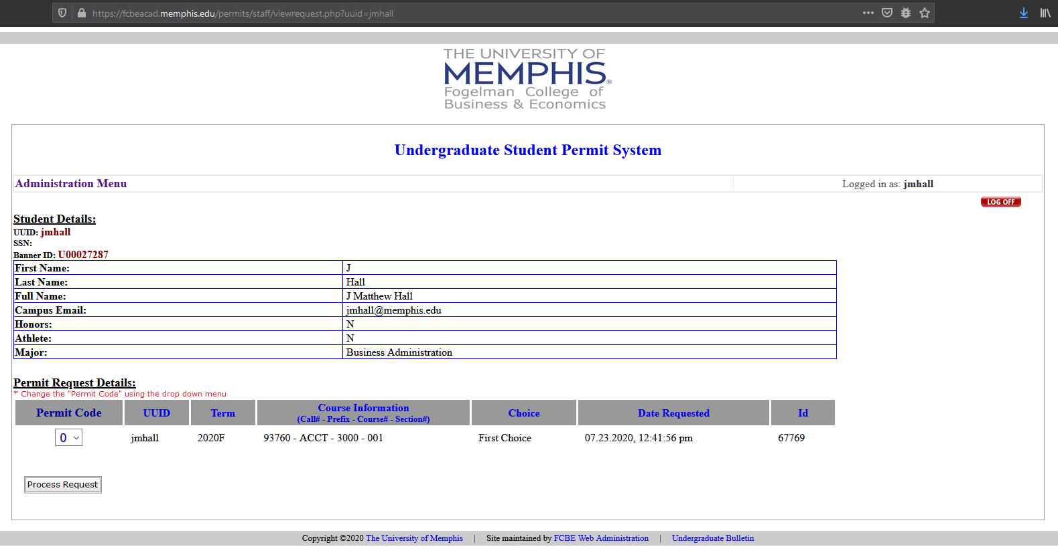

Student Permit Request – Details – Dropdown

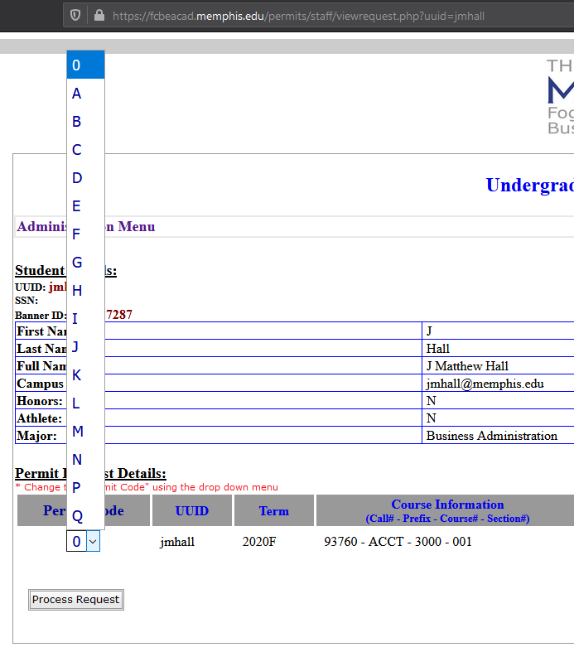This drop-down is changing.

How will you want the options to read?

* Abbreviated?
* Code / Message shorthand?

Student Permit Request – Confirmation

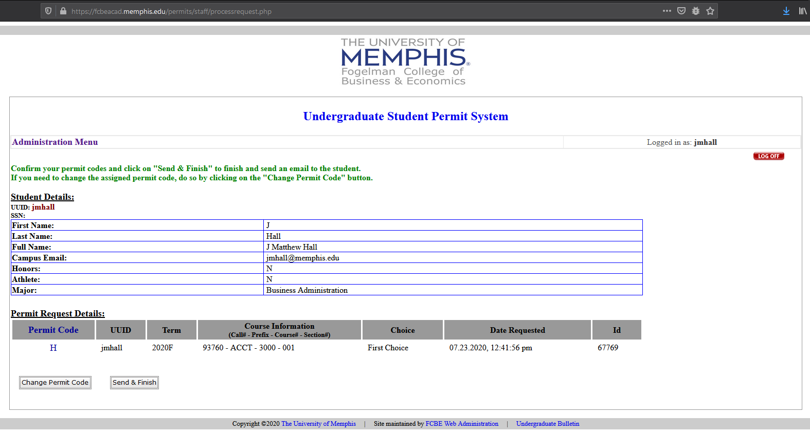

Student Permit Request – Notice Sent

